MANGOCHI CATHOLIC DIOCESE MOCK EXAMINATIONS

2025 MALAWI SCHOOL CERTIFICATE OF EDUCATION
PHYSICS
Tuesday, 20 May 2025 Subject Number: M164/I
Time Allowed: 2 Hrs.
8:00 – 10:00 am
PAPER I
(100 marks)

Question Number | Tick if answered | Do not write in these columns
1
2
3
4
5
6
7
8
9
10
11
12
13
 | Total
Instructions

- This paper contains 8 printed pages, please check.
- Write your examination number at the top of each page.
- This paper has two sections: A and B
- Answer all the questions.
- Use of scientific calculator is allowed.
- In the table provided on this page, tick against the question number you have answered.
- Hand in your paper to the invigilator when time is called to stop writing.

© 2025 MH DIOCESE Turn Over

SECTION A (70 marks)
Answer all questions in this section
1. (a) State two shortcomings affecting scientific investigations
(i)________________________________________________________________ (1 mark)
(ii)________________________________________________________________(1 mark)

(b)A reading on a measuring cylinder is 30cm³. Halliet added 50drops of water 0.1cm³ each. Find the new reading

(4 marks)
(c)Give one way of communicating a scientific investigation
_________________________________________________________________________(1 mark)
2.(a) What is the difference between natural and induced radioactivity
__________________________________________________________________________________________________________________________________________________________________________________________________________________________________________________(2 marks)
(b)The following is a nuclear equation between Hydrogen-2 and Hydrogen -3
1
3
2
H + H ___________ + n
0
1
1
- Copy and complete the equation (1 mark)
- Name the radioactivity presented in the equation
______________________________________________________________________( 1mark)
- Explain the importance of the process shown on the equation
_______________________________________________________________________________________________________________________________________________________________________________________________________________________________(3 marks)
- (a) Figure 1 Shows a 3.08g cyndrical block of wood placed on the bench.
14cm
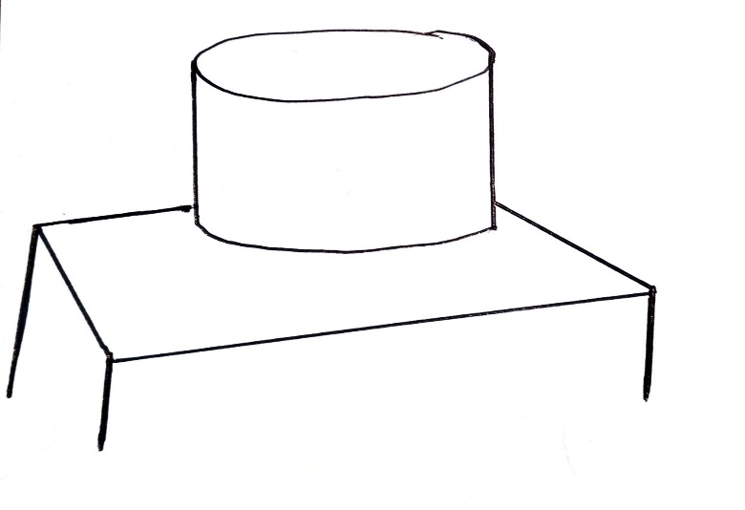

continued/…
If the diameter of the block is 14cm, calculate the pressure exerted by the wood on the bench.

( 5 marks)
(b) Explain why sinking of tyres of a car into soft sand is prevented by letting off some air in the tyres.
____________________________________________________________________________________________________________________________________________________________________________________________________________________________________________________________________(2 marks)

- (a) Figure 2. Is showing circuits and signals presented on the graph
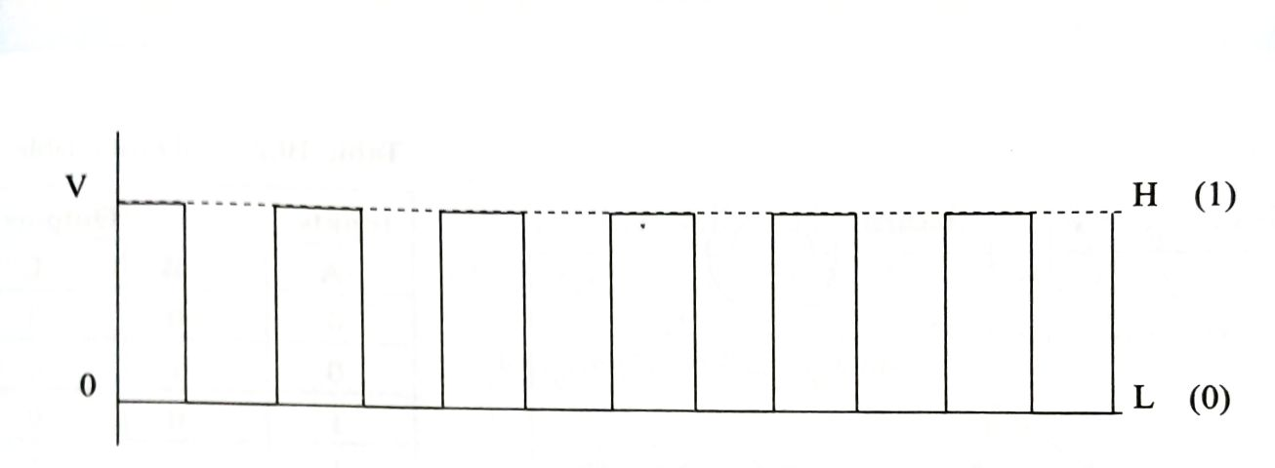
Figure 2
- Name the signal
_____________________________________________________________________(1 mark)
- Give two characteristics of the signal
__________________________________________________________________________________________________________________________________________________(2 marks)
(b) Describe how N-type semiconductor is produced
____________________________________________________________________________________________________________________________________________________________________________________________________________________________________________________________________________________________________________________________________________________________________________________________________________________________(4marks)
- (a) State the law of conservation of mechanical energy
_________________________________________________________________________________________________________________________________________________________________(1mark)
(b) Explain why energy used to pull an object on an inclined plane is greater than the energy required to lift the object on the same vertical point.
______________________________________________________________________________________________________________________________________________________________________________________________________________________________________________________________________________________________________________________________________(3 marks)
continued/…
Figure 3. Shows energy changes on a simple pendulum
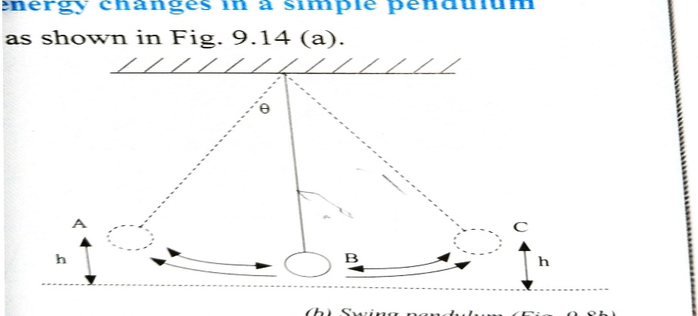
Figure 3
(c) Describe the energy changes from point A to C
At A________________________________________________________________________(1 mark)
At B ________________________________________________________________________(1mark)
At C ________________________________________________________________________( 1mark)
- (a) An object stars from 30m/s to rest in 5 seconds. calculate the deceleration

(3 marks)
(b) Figure 4 is a graph of activity against time
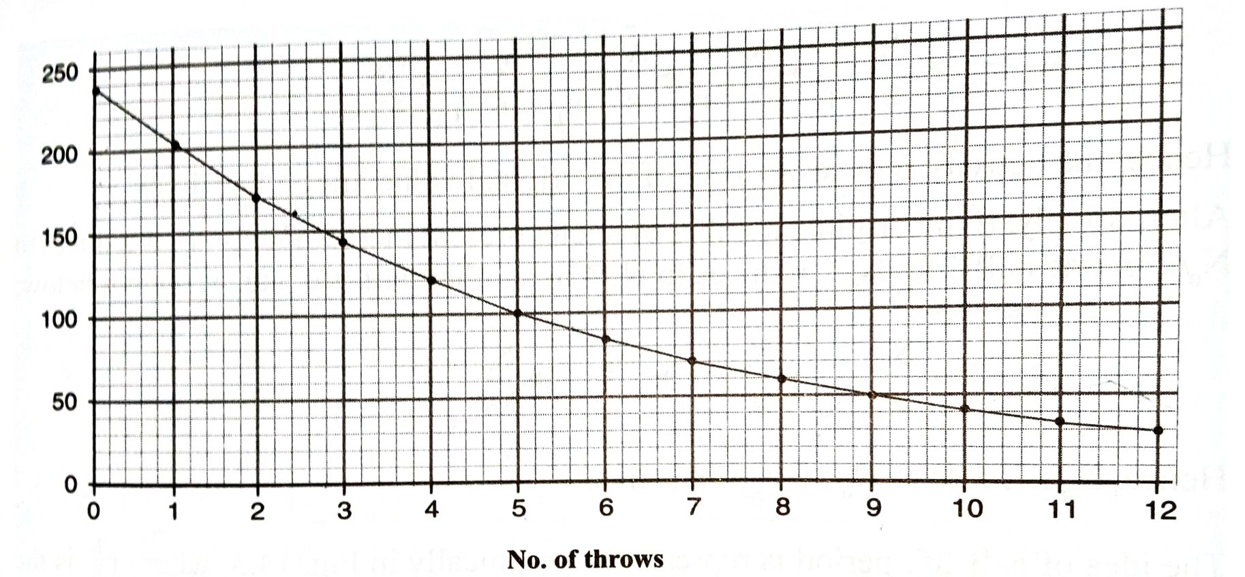
Activity
Time(s)
Figure 4
- How long does it take 160 particles to decay
_____________________________________________________________________( 1mark)
- Use the graph to determine half-life of the substance
________________________________________________________________________________________________________________________________________________________________________________________________________________________________(3 marks)
continued/…

- (a) State Faradays’ law
_______________________________________________________________________________________________________________________________________________________________(1 mark)
(b)Explain why a transformer uses a complete core (loop)
__________________________________________________________________________________________________________________________________________________________________________________________________________________________________________________(2 marks)
(c) Describe how a spring balance is calibrated
__________________________________________________________________________________________________________________________________________________________________________________________________________________________________________________________________________________________________________________________________________________________________________________________________________________________( 4marks)
- Figure 5 is an electromagnetic spectrum
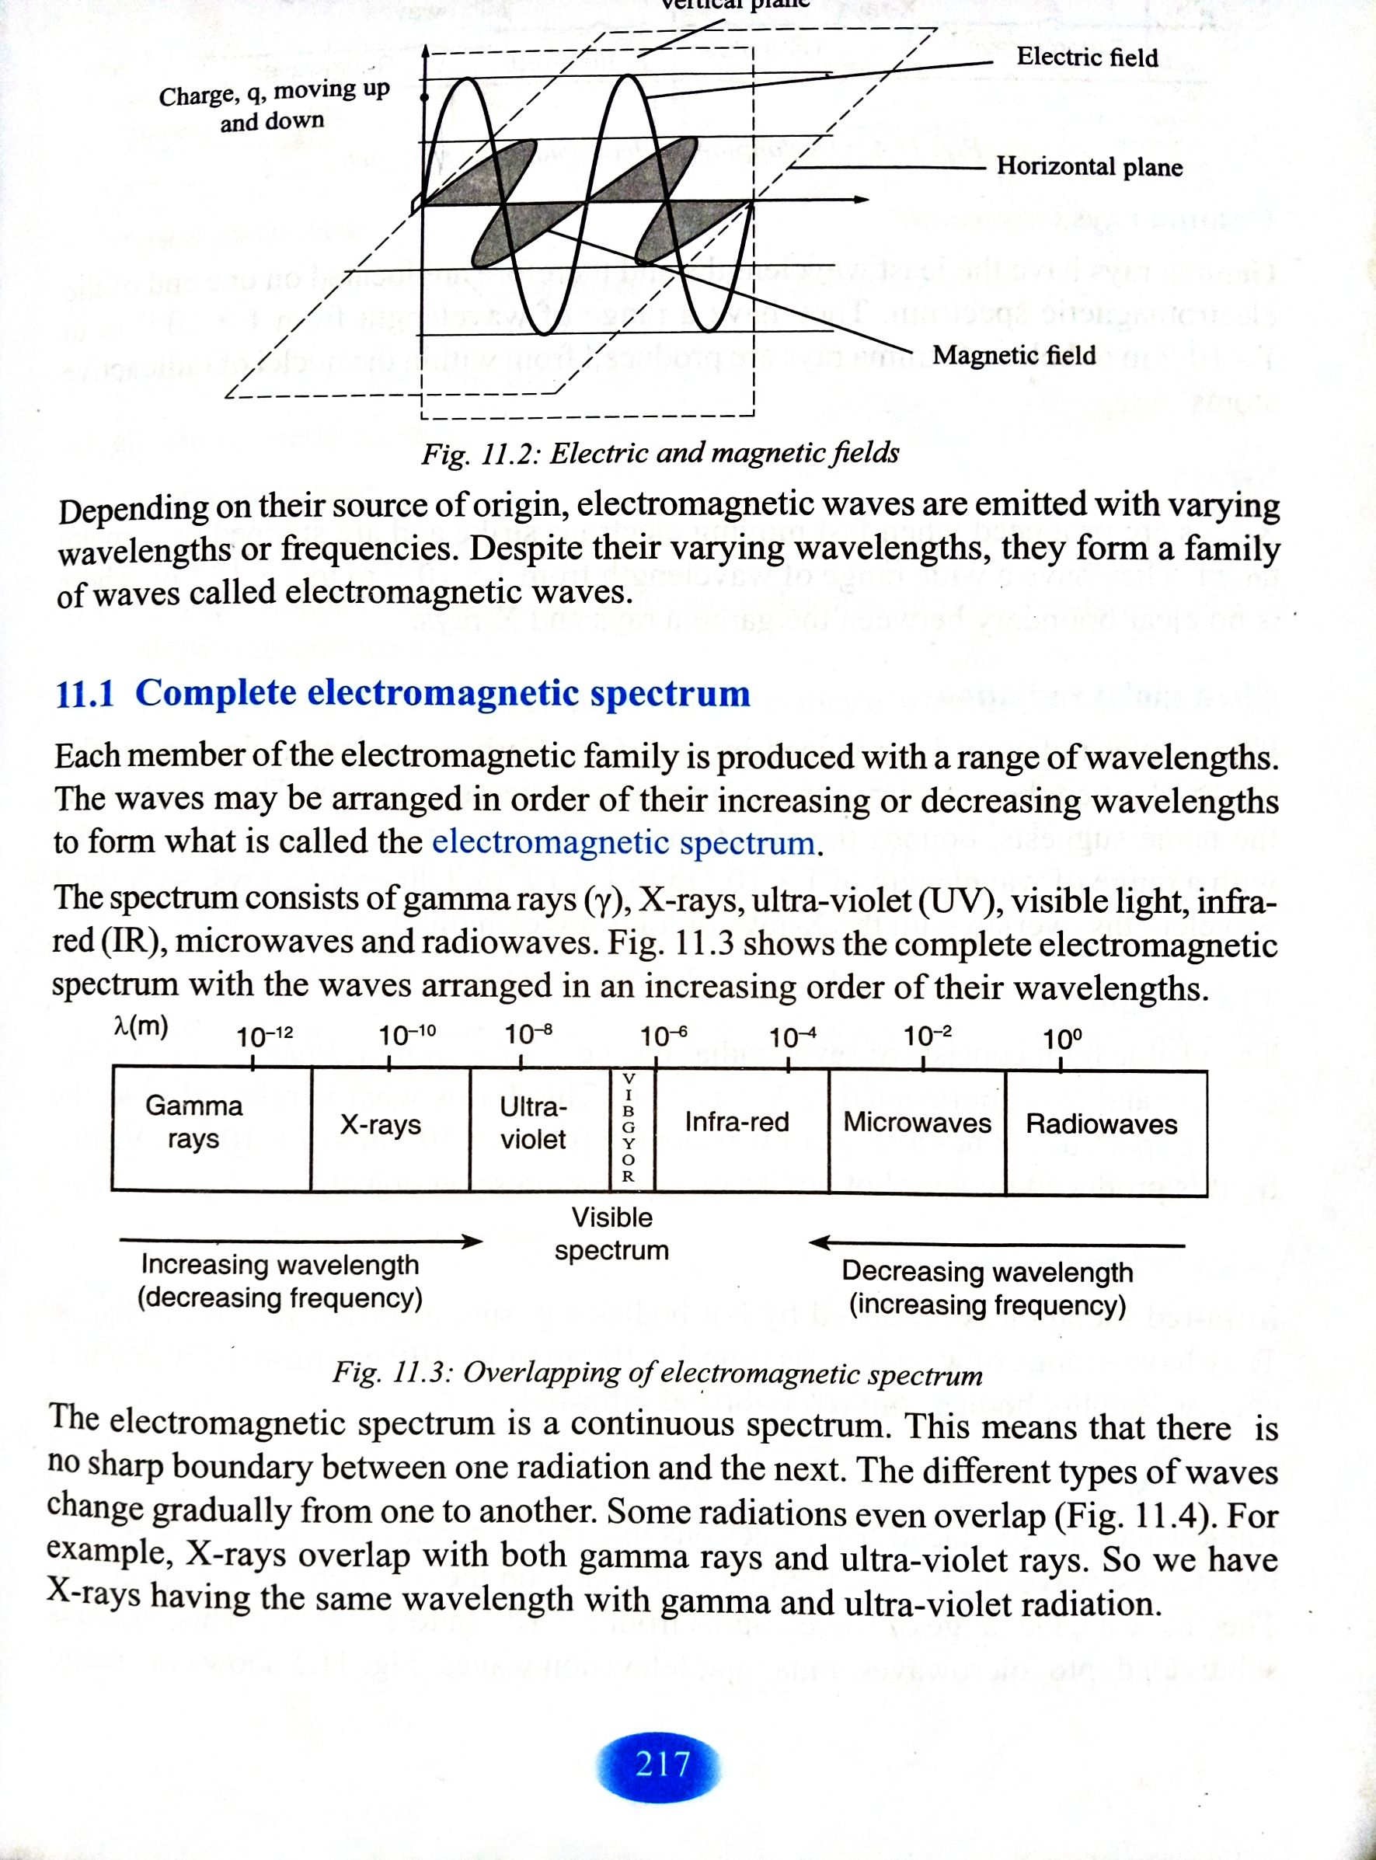
Q
P
- Identify electromagnetic waves P and Q
P______________________________________________________________________ (1 mark)
Q_____________________________________________________________________ (1 mark)
- Describe the following from P to Q
- Frequency
__________________________________________________________________________________________________________________________________________________________________________________________________________________________________(1 mark)
- Wavelength
__________________________________________________________________________________________________________________________________________________________________________________________________________________________________(1 mark)
- Why is electromagnetic Q called thermal radiation
_________________________________________________________________________(1 mark)

- Give two importance of visible spectrum
(i)______________________________________________________________________________________________________________________________________________________________(1 mark)
(ii)_____________________________________________________________________________________________________________________________________________________________ (1 mark)
continued/…
- Figure 6 is an instrument used to determine pressure of the gas
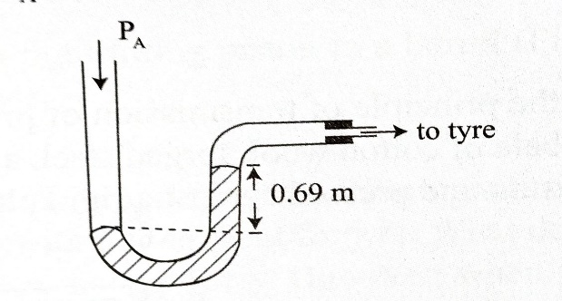
Figure 6
- Name the instrument
_________________________________________________________________________ (1 mark)
- Given that the density of mercury is 13.6 x 10³ kg/m³ and atmospheric pressure is 1,02x 10⁵Pa. calculate the gas pressure

(3 marks)
- Describe how you can determine the focal length of the lens using a distant object
__________________________________________________________________________________________________________________________________________________________________________________________________________________________________________(3 marks)
10 . (a) Describe the similarities between a camera and a human eye _________________________________________________________________________________________________________________________________________________________________________________________________________________________________________________________________________________________________________________________________________________________________________________________________________________________________________________________(3 marks)
(b) Describe the action of centrifuge during separation of liquids of different densities
_______________________________________________________________________________________________________________________________________________________________________________________________________________________________________________________________________________________________________________________________________________________________(4 marks)

continued/…
SECTION B (30 marks)
Answer all the three questions in this section in an essay form in the spaces provided.
- (a) Show that the liquid pressure exerted on the surface of open container is expressed as
P = dhg
Where P is the pressure of the liquid, d is the density of the liquid, h is the column height of the liquid in the container and g is the acceleration due to gravity.
__________________________________________________________________________________________________________________________________________________________________________________________________________________________________________________________________________________________________________________________________________________________________________________________________________________________________________________________________________________________________________________________________________________________________________________________________(6 marks)
(b) Describe how a candle maintains burning when heated.
___________________________________________________________________________________________________________________________________________________________________________________________________________________________________________________________________________________________________________________________________________________________________________________________________________________________(4 marks)
- (a) With the aid of a circuit diagram describe rate of flow charges expressed as
Current (I) = Charge (Q)/Time (t)

___________________________________________________________________________________________________________________________________________________________________________________________________________________________________________________(6 marks)
(b) Describe how a direct current (dc) motor works.
___________________________________________________________________________________________________________________________________________________________________________________________________________________________________________________________________________________________________________________________________________________________________________________________________________________________________________________________________________________________________________________________________________________________________________________________________(4 marks)
continued/…

- (a) Describe beta radiation
__________________________________________________________________________________________________________________________________________________________________________________________________________________________________________________________________________________________________________________________________________________________________________________________________________________________________________________________________________________________________________________________________________________________________________________________________________________________________________________________________________________________________________________________________________________________________________ ( 5 marks)
(b) With the aid of a diagram describe how photovoltaic cell works.

____________________________________________________________________________________________________________________________________________________________________________________________________________________________________________________________________________________________________________________________________________________________________________________________________________________________________________________________________________________________________________________________________________________________________________________________________________________________________________( 5 marks)

END OF QUESTION PAPER
NB: This paper contains 8 printed pages

